

Suspicious activity detector

TEAM ALPHA

Vyshali C | Bharat Chandra | S Srinibha

# Introduction

Artificial Intelligence:

Artificial intelligence is the intelligence of the machines and the branch of computer science which aims to create it. This includes learning (the acquisition of information and rules for using the information), reasoning (using rules to reach approximate or definite conclusions) and self-correction. There are various programming languages like Lisp, Prolog, C++, Java and Python, which can be used for developing applications of AI. Among them, Python programming language gains a huge popularity and the reasons are as follows −

1. Simple syntax and less coding
2. Inbuilt libraries for AI projects such as NumPy, SciPy, matplotlib, nltk, etc.

## Objective of research

There have been a lot of researches in the field of Artificial Intelligence. According to the father of Artificial Intelligence, John McCarthy, it is “The science and engineering of making intelligent machines, especially intelligent computer programs”. Our project is a contribution towards artificial intelligence and deals with the detection of suspicious activity. In this project, we extract a frame every 5 seconds and then we train the frames as abnormal activity and normal activity. With at 77% accuracy we continue to test the video by again converting them into frames for every 5 seconds.

## problem statement

Crime rates are without a doubt ending up being extra frightening these days and also for that reason we should think of means to secure our residence as well as loved ones from any kind of those kind of risks. It’s a good thing that innovation has actually made it feasible to boost our residence’s safety and security. An example of this is an electronic surveillance system and it can make a huge difference in the protection of your house. A lot of cameras are installed in many places for surveillance, but the surveillance is done by human, and it is done only if there is a report of anomaly behavior, otherwise the videos are kept as archives, and never use. Developing algorithms for automatic detection of Human movements, and making appropriate decision when there is any suspicious behavior, it will result to real time processing of Human activities in public places. It will help in security, and ensuring public safety.

## literature review

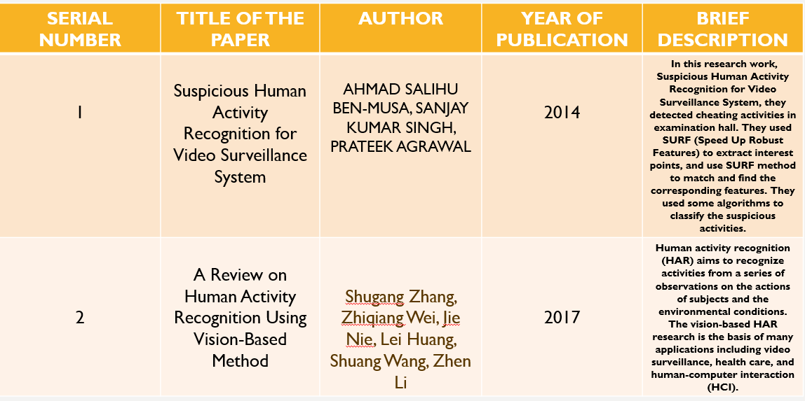

## data collection

The dataset required was extracted from <https://github.com/mohanrajmit/Human-Action-Classification-> . The dataset consists of 3 scenes containing of the both normal and abnormal scenarios which is used to train and test the code. The first scene is a crowd wandering in a garden, the second scene is a crowd of people in a hallway and the third scene is a crowd of people in front of a shopping mall.

## methodology

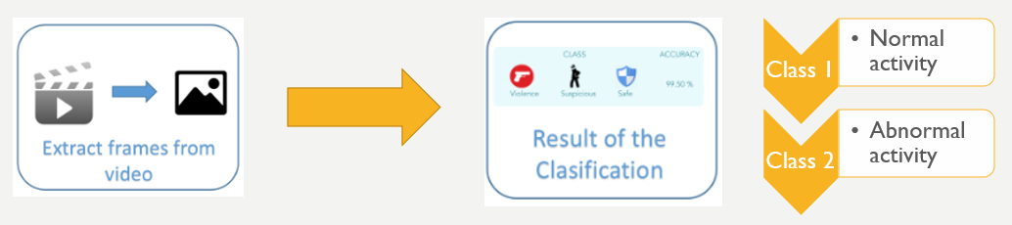

## future work

We will improve some algorithms for fast and reliable system of recognizing any human activity. We will also work on other biometric features to incorporate variation into Suspicious activity detector. We will develop algorithms that can predict the activities with high certainty and efficiency to prevent criminal activities before occurring.

## references

1. <https://dzone.com/articles/video-analysis-to-detect-suspicious-activity-based>
2. <https://www.tutorialspoint.com/artificial_intelligence_with_python/artificial_intelligence_with_python_primer_concepts.htm>
3. <https://www.researchgate.net/publication/264037010_Suspicious_Human_Activity_Recognition_for_Video_Surveillance_System>
4. <https://databricks.com/blog/2018/09/13/identify-suspicious-behavior-in-video-with-databricks-runtime-for-machine-learning.html>

## conclusion

In this project, we were successfully able to classify the video into normal and abnormal activity. We implemented Suspicious activity detection, which will be useful in detecting and recognizing normal and abnormal activities anywhere. Human supervisors are error prone, and their efficiency is affected by fatigue, sickness and any other factor, hence this system is perfect for surveillance.